**Experiment No. 10**

**Aim: To determine the charge distribution on a conducting thin wire by Moment Method using Matlab.**

**Software required: Matlab 7.0**

**Theory:**

To determine the linear charge density on a finite straight segment of thin charged conducting wire of length L=1 m and radius r, we assume that the charge density is piecewise constant over the length and the electric potential is one volt. If the radius is very small as compared to the length r<<L, the equation of the electric potential is written in integral form. To ease the problem, we subdivide the wire in N sub segments, each of length. We choose N points of observation mx on the surface and the charge density is piecewise constant onto each segment. The integral equation will be transformed to linear equation in N equation with N unknown system. We use the method of moments for solving this system.

The potential at all points is written as



In practice, it does not stretch to the source, a more useful form of Coulomb's law for the charges can be offset at an arbitrary point r'. In this case the distance between the source and the observation point can be written as r=|r- r'|.  Thus, a more generic form of Coulomb's law may be written as



Consider a thin conducting wire of radius r, length L oriented along the x axis, as shown in Figure 1. Let the wire be maintained at a potential of V0 .Our goal is to determine the charge density ρ along the wire using the moment of method.

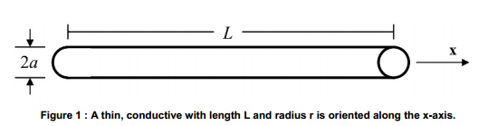

If the radius of the wire is very small compared to the length (a<<L), the electric potential on the wire can be expressed by the following equations





Where the functions K(x,t) and g(t), the limits a and b are known. The unknown function φ(x) is to be determined; the function K(x,t) is called the kernel of the equation. The moment method is a common numerical technique used in solving such integral equations.

In order to transform previous equation into a system of linear equation and applied the moment method, we subdivide the wire into N sub segments each of length $∆x=\frac{L}{N}$ as shown in figure 2. In each sub segment, we assume that the charge density has a constant value so that q(x) is piecewise constant over the length of the wire.

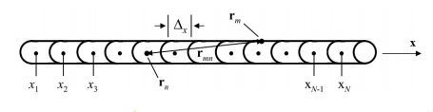

Figure 2: Division of the wire into N segments

We then define an estimation function λe(x) that approximates of the unknown function λ(x) by expressing it as a linear combination of discrete basis functions. Letting αn denote the basic functions and fn(x’) denote the weighting coefficients, this is written as



Where αn are unknown weighting coefficients, and fn(x’) is a set of pulse functions that are constant on one segment but zero on all other segments

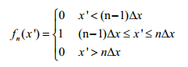



Using the above definition of the pulse function, we can rewrite this as

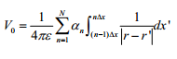

We obtain a sum of integrals, each over the domain of a single pulse function. Fix the source points into the wire axis and the observation point into the wire surface for no singularity in the integrand. The denominator of the integrand now becomes



Thus, the previous equation can be written as

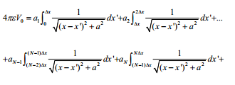

The above expression represents a system of N linear equations with N unknowns. We solve this equation by common matrix algebra routines if we can obtain N equations in N unknowns. To solve it we choose N independent observation points mx on the surface of the wire, each at the center of wire segment. This will result in one equation of the above form corresponding to each observation points. For each N point we can reduce above equation to

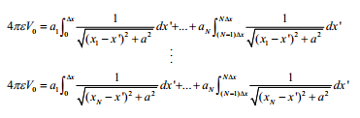

We can write above equation as a system of N x N linear equa

]tions more concisely using matrix notation as



Where each Zmn term is equal to

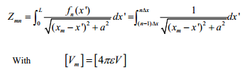

The Vm column matrix has all terms equal to 4πε0, and the αn values are the unknown charge distribution coefficients. Solving for αn gives



Thus, the equation



in matrix form becomes

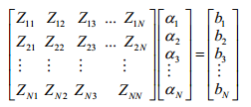

And the right side bm vector elements are equal to 4πεV0.

And final form for this equation is

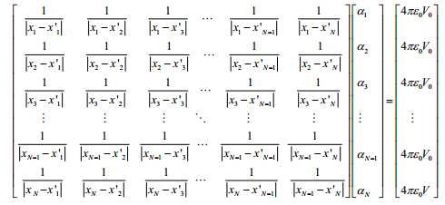

Only the first row of the matrix needs to be computed. Since the wire is conducting, a surface charge density σs is expected over the entire surface. Hence at the center of each segment

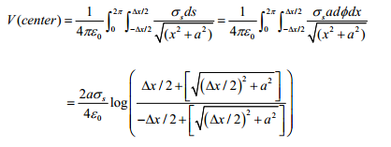

Assuming Δ<<a

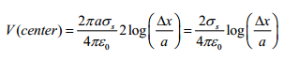

Where σL=2Πaσs. Thus, the self terms m=n are



Thus, the final form of the equation now becomes

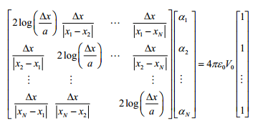

**Result:**

**Conclusion:**